
a
Company
Logotype

Cone Beam Computed Tomography- Report



Porur Dental X-rays & CBCT

Patient Name : Mr. Selvaraj | Date of Report : 30.03.2024
Age/ Gender : 67 years/ Male | Region of Interest : CBCT Sectional Maxilla
Referring doctor: Dr. S.M.M. Moulvi | Indication : Implant assessment
Clinical Notes: Nil
PATIENT INFORMATION

CBCT- Sectional Maxilla provided
CBCT – IMAGE DETAILS

RADIOGRAPHIC INTERPRETATION

- Completely missing crown and root portion in relation to: 24, 25, 26, 27, 28.
- Presence of a hyperdense screw like structure within the alveolar region in relation to 25 region is evident.
- The maxillary alveolar ridge is present with normal trabecular pattern.
- Root stumps: 26, 27.
 | 24 region | 26 region | 27 region
Sub-Crestal (in mm) | 5.91 | 12.66 | 12.97
Mid- Crestal (in mm) | 6.93 | - | 12.94
Distance between the alveolar ridge and floor of the maxillary sinus (in mm) | 20.57 | 6.49 | 6.65
IMPLANT ASSESSMENT

RADIOGRAPHIC IMPRESSION

- Partially edentulous maxillary arch.
- Implant in relation to 25.
- Root stumps: 26, 27.

Kindly correlate with clinical findings


IMAGES FOR REFERENCE

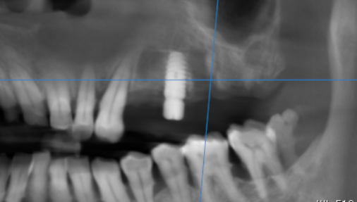

3-DIMENSIONAL VIEW
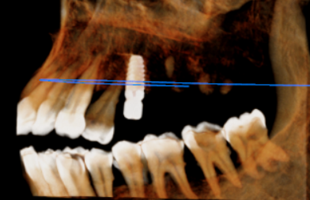

CROSS SECTIONAL VIEW

24 region | 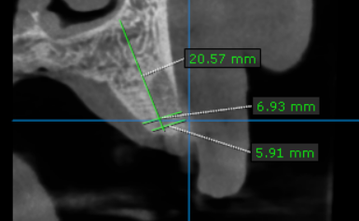
26 region | 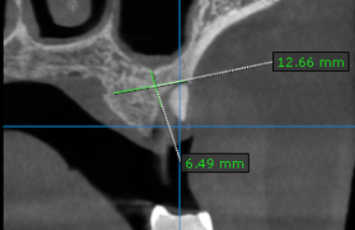
27 region | 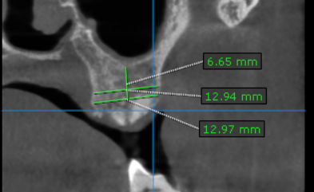

**** End of report ****

